PL/SQL : Exercise 1: Control Structures:

Step 1: Create Tables
CREATE TABLE Customers (
CustomerID NUMBER PRIMARY KEY,
Name VARCHAR2(50),
Age NUMBER,
Balance NUMBER,
IsVIP VARCHAR2(5)
);

CREATE TABLE Loans (
LoanID NUMBER PRIMARY KEY,
CustomerID NUMBER,
InterestRate NUMBER,
DueDate DATE,
FOREIGN KEY (CustomerID) REFERENCES Customers(CustomerID)
);

SCREEN SHOT: 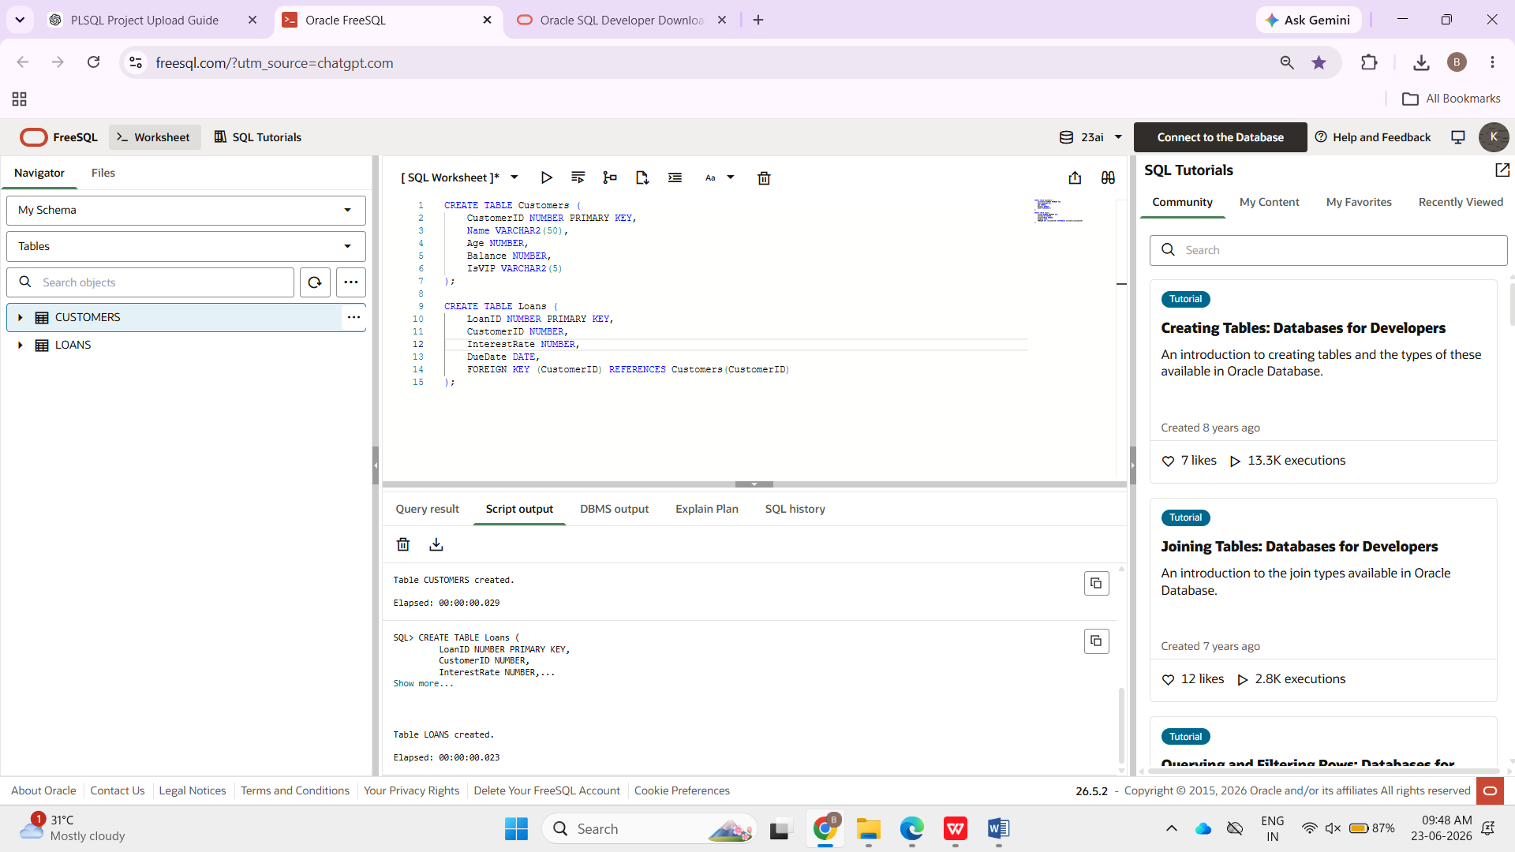
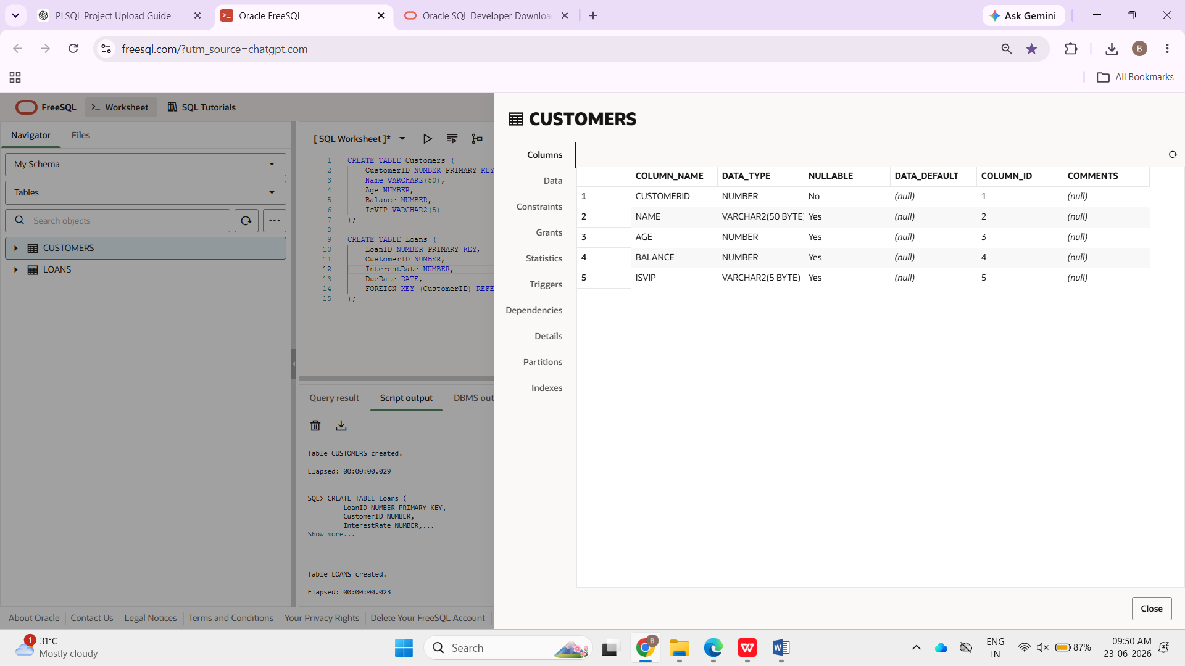
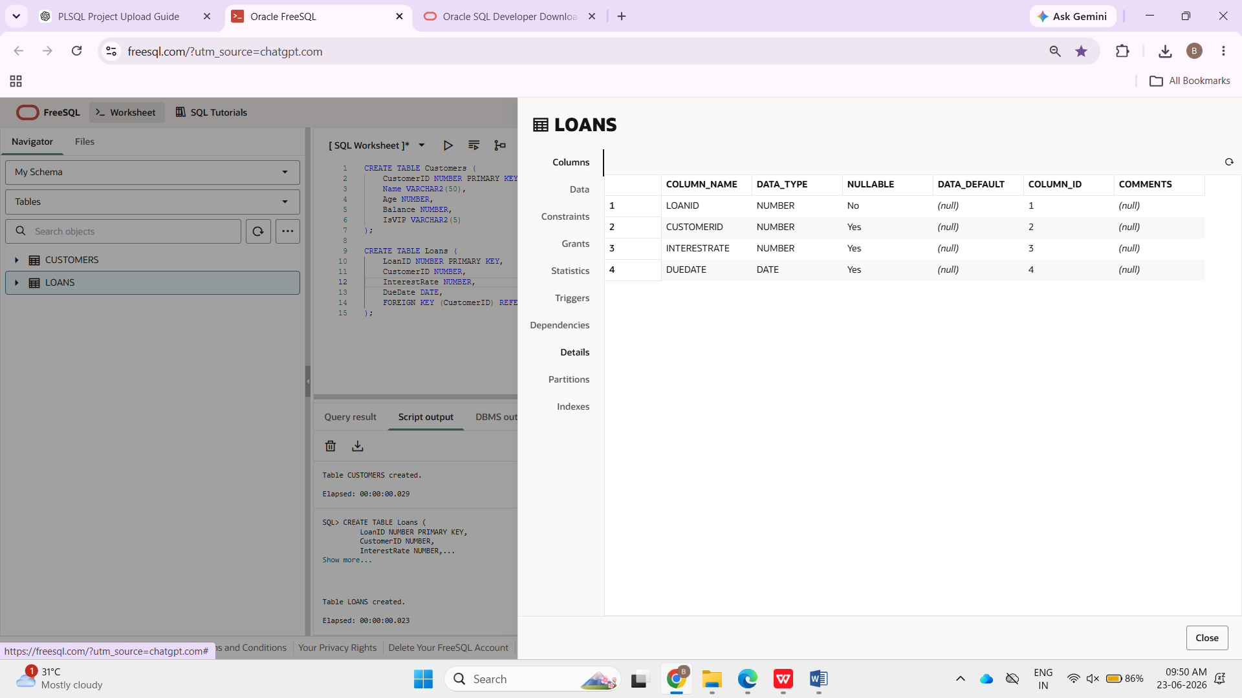
STEP 2 : INSERT THE NAMES AND VALUES IN THE TABLE
INSERT INTO Customers VALUES (1,'Ravi',65,15000,'FALSE');
INSERT INTO Customers VALUES (2,'Priya',45,12000,'FALSE');
INSERT INTO Customers VALUES (3,'Kiran',70,8000,'FALSE');

INSERT INTO Loans VALUES (101,1,10,SYSDATE+20);
INSERT INTO Loans VALUES (102,2,12,SYSDATE+40);
INSERT INTO Loans VALUES (103,3,11,SYSDATE+10);

COMMIT;

SCREEN SHOT:
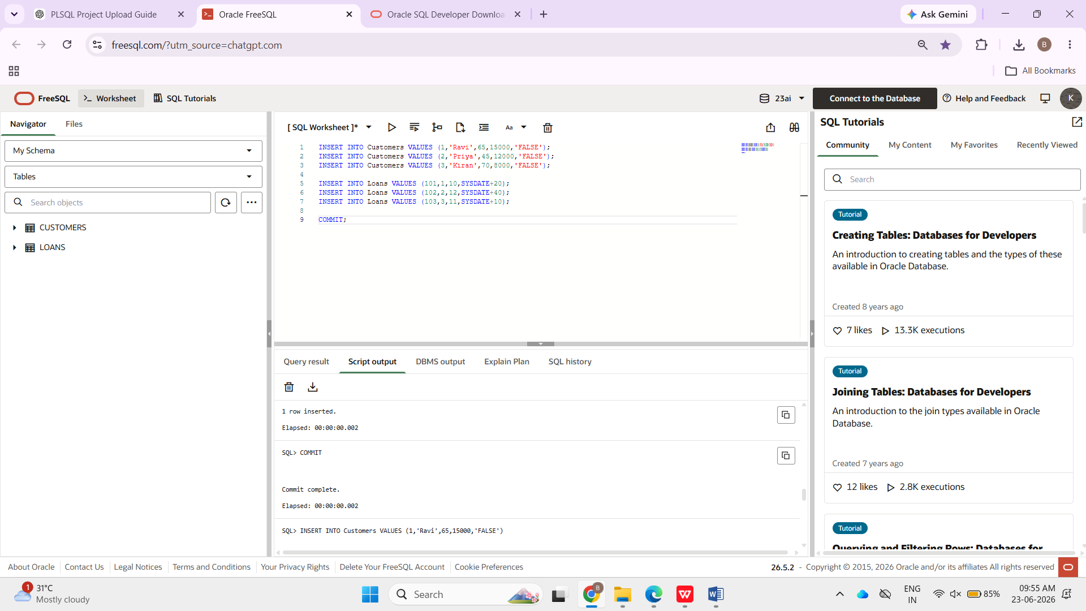
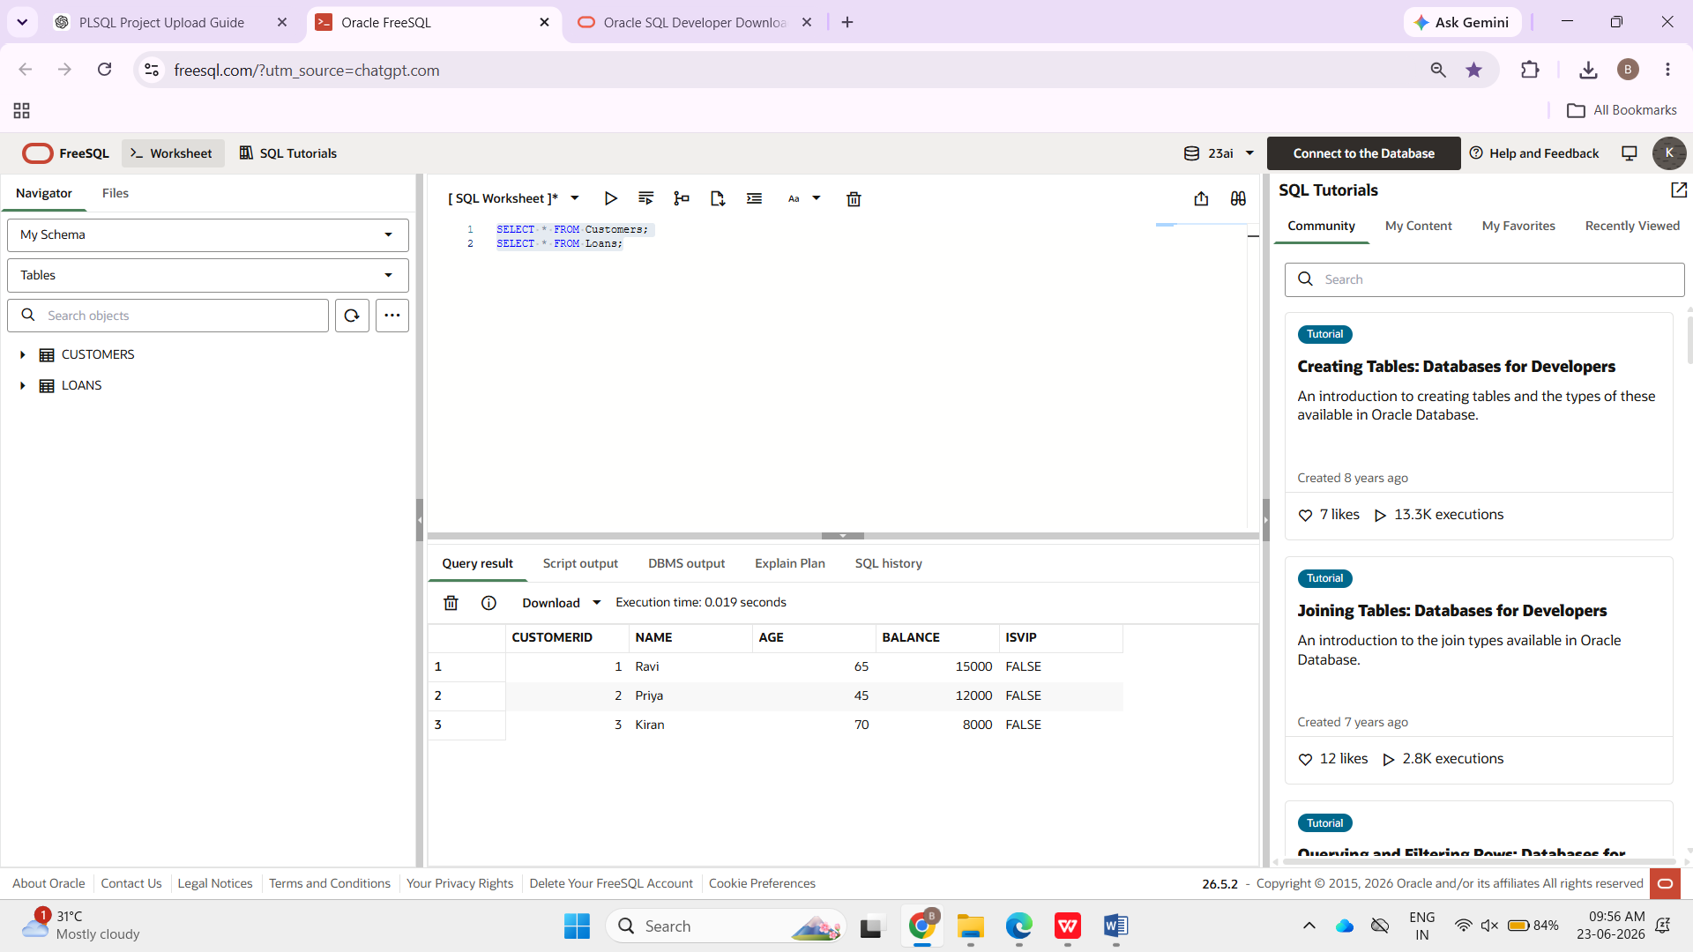
SENARIO 1: BEGIN
FOR cust IN (
SELECT c.CustomerID,
c.Age,
l.LoanID
FROM Customers c
JOIN Loans l
ON c.CustomerID = l.CustomerID
)
LOOP
IF cust.Age > 60 THEN
UPDATE Loans
SET InterestRate = InterestRate - 1
WHERE LoanID = cust.LoanID;
END IF;
END LOOP;

COMMIT;
END;
/
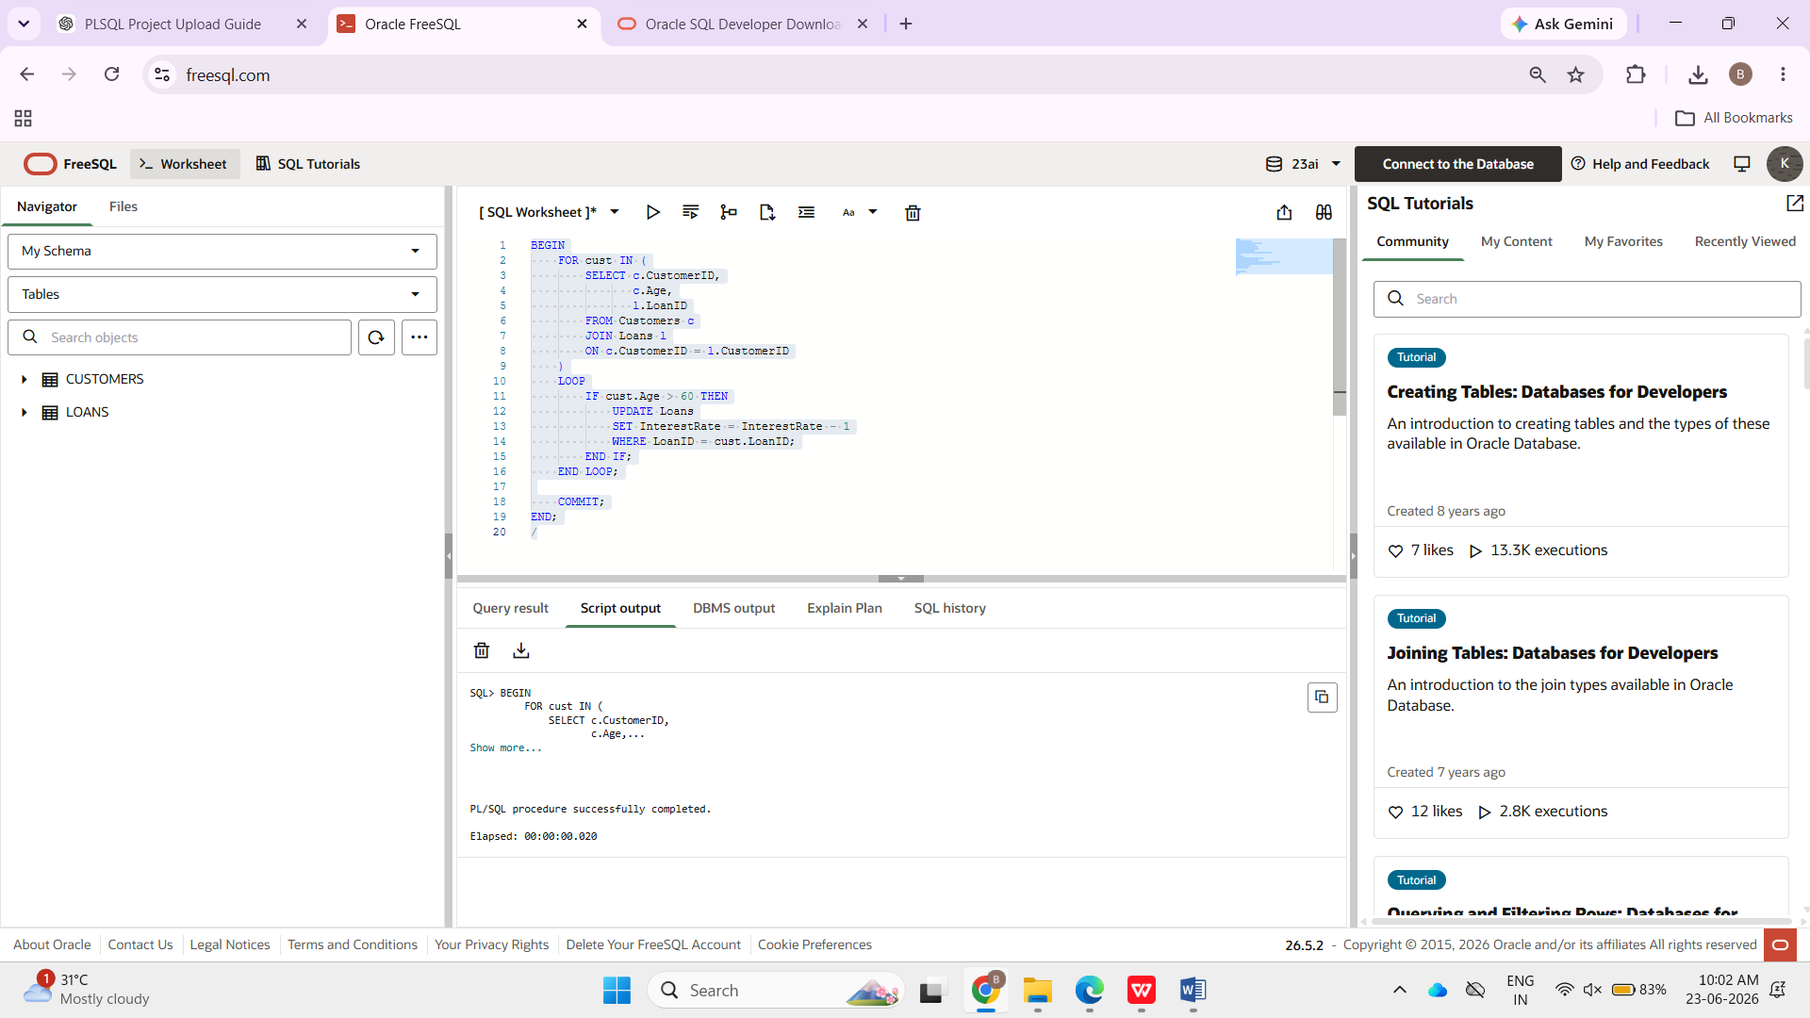
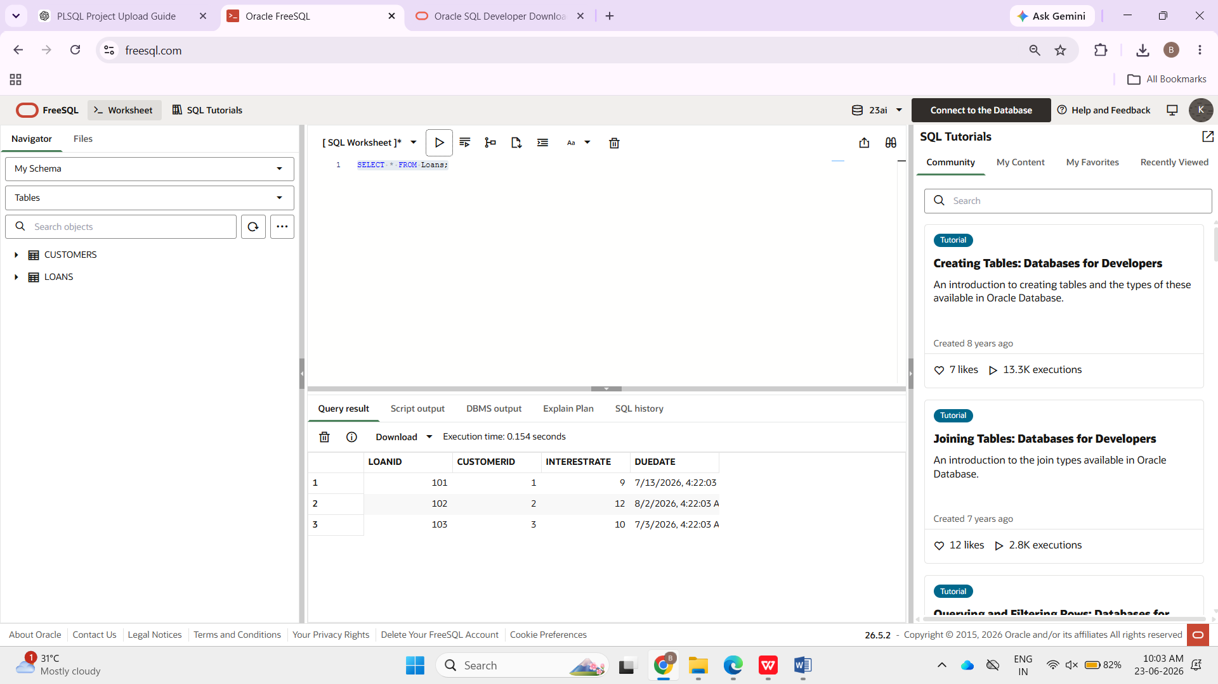
Next: Scenario 2 (VIP Customers)
BEGIN
FOR cust IN (
SELECT CustomerID, Balance
FROM Customers
)
LOOP
IF cust.Balance > 10000 THEN
UPDATE Customers
SET IsVIP = 'TRUE'
WHERE CustomerID = cust.CustomerID;
END IF;
END LOOP;

COMMIT;
END;
/
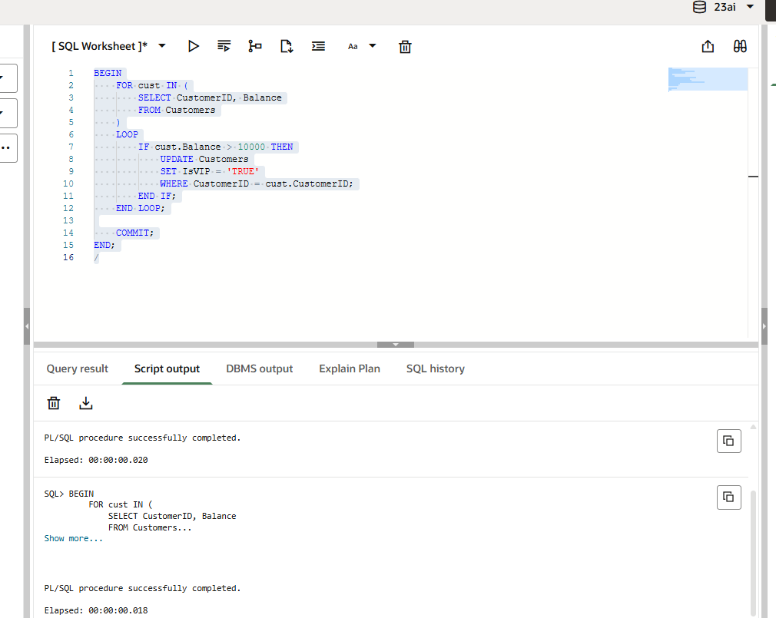
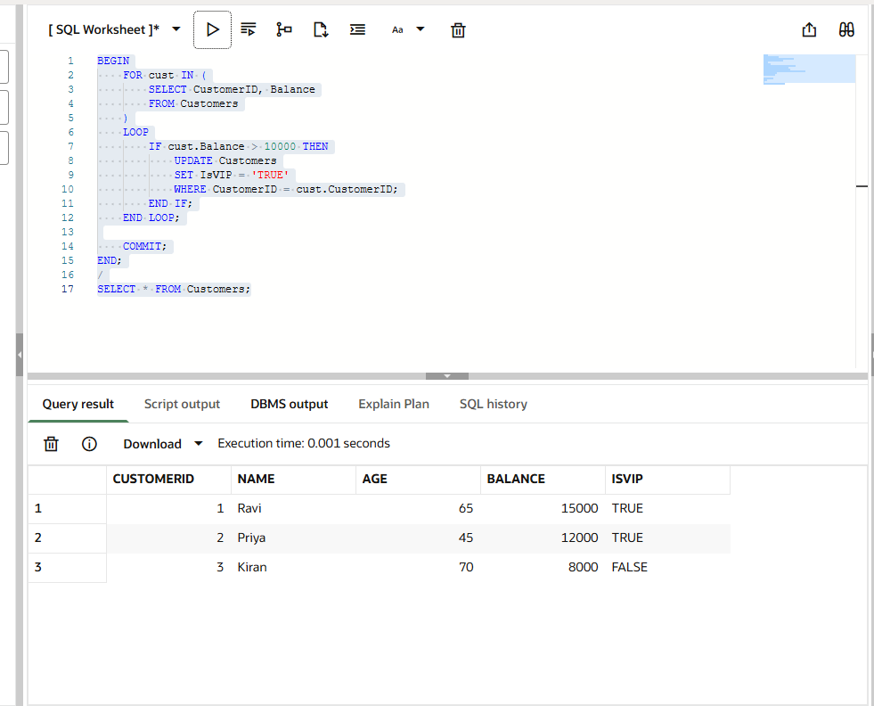
Scenario 3:
BEGIN
FOR loan_rec IN (
SELECT c.Name,
l.LoanID,
l.DueDate
FROM Customers c
JOIN Loans l
ON c.CustomerID = l.CustomerID
WHERE l.DueDate BETWEEN SYSDATE
AND SYSDATE + 30
)
LOOP
DBMS_OUTPUT.PUT_LINE(
'Reminder: Loan '
|| loan_rec.LoanID
|| ' for '
|| loan_rec.Name
|| ' is due on '
|| TO_CHAR(loan_rec.DueDate,'DD-MON-YYYY')
);
END LOOP;
END;
/
